Databases 6G4Z0016 Labsheet

# Topic 4 – GROUP BY

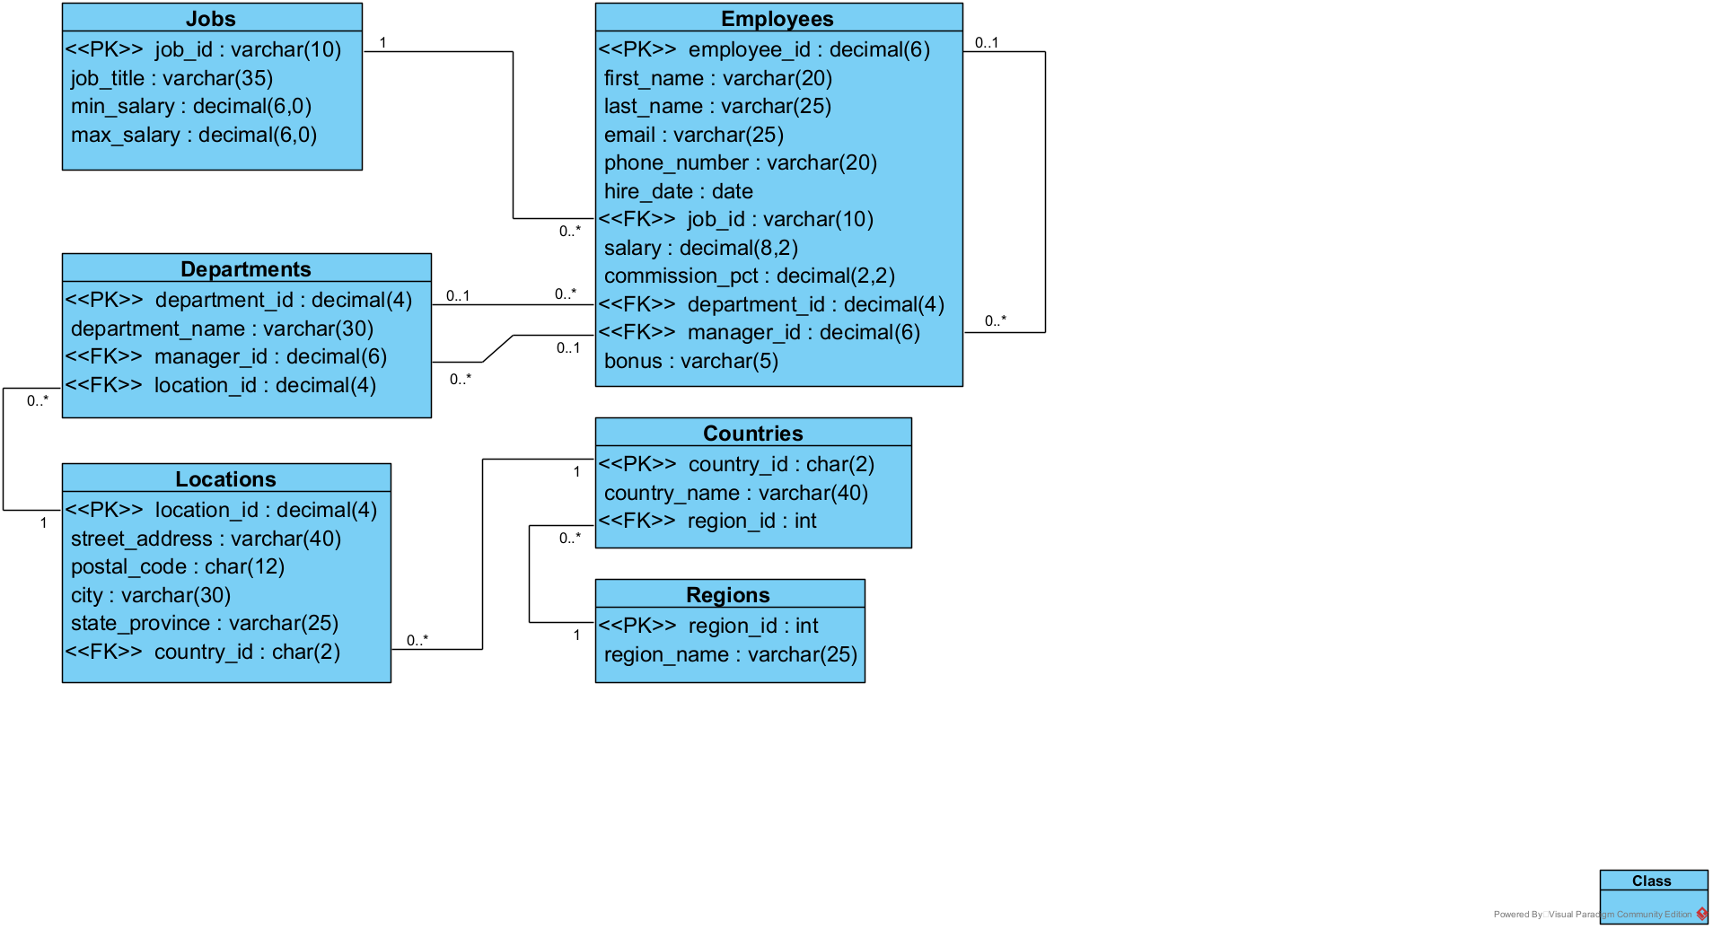

# Part One – Joins Recap

### Q1: List the countries and the regions they are in

SELECT country_name, region_name  
FROM Countries  
INNER JOIN Regions **[BLANK]**;

### Q2: List every pair of employees who have the same job

SELECT e.first_name, e.last_name, c.first_name, c.last_name, job_title  
FROM Employees AS e  
**[BLANK]**  
WHERE e.employee_id < c.employee_id;

### Q3: List the departments in the UK

SELECT department_name  
FROM Departments  
**[BLANK]**  
WHERE country_id = 'UK';

### Q4: List the employees who work in the same city where that city does not begin with an S

SELECT e.first_name, e.last_name, c.first_name, c.last_name, l1.city  
FROM Employees AS e  
**[BLANK]** Departments**[BLANK]   
[BLANK]** Locations **[BLANK]**  
**[BLANK]** Employees **[BLANK]**  
**[BLANK]** Departments **[BLANK]**  
**[BLANK]** Locations **[BLANK]**  
WHERE l1.city = l2.city  
AND e.employee_id < c.employee_id  
AND **[BLANK]**;

### Q5: List the departments that don’t have managers

SELECT department_name, manager_id  
FROM Departments  
**[BLANK]**;

### Q6: List the departments whose manager's surname ends in s or t or who don't have a manager.

SELECT department_name, first_name, last_name  
FROM Departments  
**[BLANK]**  
WHERE **[BLANK]**

### Q7: List the departments in order of their country and then alphabetically

SELECT department_name, country_name  
FROM Departments  
**[BLANK]**  
INNER JOIN Countries USING(country_id)  
**[BLANK]**;

### Q8: List all the employees whose phone number doesn't start with the same 3 digits as their manager's phone number

SELECT e.first_name, e.last_name, e.phone_number,   
 m.first_name, m.last_name, m.phone_number  
FROM Employees AS e  
**[BLANK]**  
**[BLANK];**

# Part Two – Group and Group BY

### Q1: Calculate the total salaries paid out in the Marketing department

SELECT department_name, **[BLANK]** AS 'total salaries'  
FROM Employees  
INNER JOIN Departments **[BLANK]**  
WHERE department_name = 'Marketing';

### Q2: Calculate the average minimum and maximum salaries available

SELECT **[BLANK]** AS 'average minimum', **[BLANK]** AS 'average maximum'  
FROM Jobs;

### Q3: Calculate the range of salaries (highest minus lowest)

SELECT **[BLANK]**  
FROM Employees;

### Q4: Calculate how many employees work in the Shipping department

SELECT department_name, **[BLANK]**  
FROM Employees  
INNER JOIN Departments USING(department_id)  
**[BLANK]**;

### Q5: Calculate how many employees work in each department

SELECT department_name, **[BLANK]**  
FROM Employees  
INNER JOIN Departments USING(department_id)  
**[BLANK]**;

### Q6: Calculate the average salary for each job to the nearest whole number (put 0 if nobody works that job). Order the results from highest to lowest

SELECT job_title, **[BLANK]** AS 'average salary'  
FROM Employees  
**[BLANK]** Jobs USING (job_id)  
GROUP BY **[BLANK]**  
ORDER BY **[BLANK]**;

### Q7: Calculate the total salaries paid in each country

SELECT country_name, SUM(salary) **[BLANK]**  
FROM Employees  
INNER JOIN Departments USING(department_id)  
INNER JOIN Locations USING(location_id)  
INNER JOIN Countries USING(country_id)  
**[BLANK]**;

### Q8: Calculate the smallest salary in each city

SELECT city, **[BLANK]**  
FROM Employees  
INNER JOIN Departments USING(department_id)  
INNER JOIN Locations USING(location_id)  
**[BLANK]**;

# Part Three – HAVING

### Q1: List the departments whose average salary is greater than 15,000

SELECT department_name, **[BLANK]**  
FROM Employees  
INNER JOIN Departments USING(department_id)  
GROUP BY department_name  
HAVING **[BLANK]**;

### Q2: List the countries with at least 3 employees

SELECT country_name, COUNT(*) AS 'number of employees'  
FROM Employees  
INNER JOIN Departments USING(department_id)  
INNER JOIN Locations USING(location_id)  
INNER JOIN Countries USING(country_id)  
**[BLANK]**;

### Q3: List the jobs where the average salary is between 3,400 and 6,700

SELECT job_title, **[BLANK]** AS 'average salary'  
FROM Employees  
INNER JOIN Jobs USING(job_id)  
GROUP BY job_title  
**[BLANK]**;

### Q4: List the jobs where there are at least 2 people working in that job

SELECT job_title, COUNT(*) AS 'number of employees'  
FROM Employees  
INNER JOIN Jobs USING(job_id)  
**[BLANK]**;

### Q5: List the departments that employ more than 1 employee whose first name starts with a vowel.

SELECT department_name, COUNT(*) AS 'number of employees'  
FROM Employees  
INNER JOIN Departments USING(department_id)  
WHERE **[BLANK]**  
**[BLANK]**;

### Q6: List the jobs, their potential salary range and actual salary range. Order the results by the size of the actual range (from highest to lowest)

SELECT job_title, **[BLANK]**AS 'potential range',   
 **[BLANK]** AS 'actual range'  
FROM Jobs  
INNER JOIN Employees USING(job_id)  
GROUP BY job_title  
**[BLANK]**;

### Q7: List the locations with only 1 or 2 departments

SELECT street_address, postal_code, city, COUNT(*) AS 'number of departments'  
FROM Locations  
INNER JOIN Departments USING(location_id)  
**[BLANK]**;

### Q8: List the phone area codes (first three digits) used by only one employee

SELECT LEFT(phone_number,3) AS 'area code', COUNT(*) AS 'number of employees'  
FROM Employees  
**[BLANK]**;

# Part Four – Deliberate Practice

### Q1: Calculate the smallest salary in the US

### Q2: List the three departments with the most employees

### Q3: List the jobs in order from the one with the most paid in salaries to the least

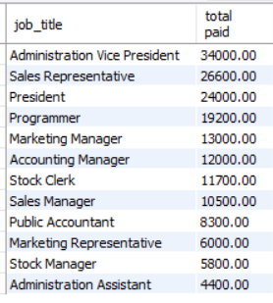

### Q4: Calculate how many employees there are in each region

### Q5: List the departments with more than 2 employees

### Q6: Find the highest paid employee

### Q7: List the department with the lowest total wage bill

### Q8: List the departments in order from the one with the highest range of salaries to the lowest

